Format of the Content of E- Portfolio

Title Page ( See Sample below)

PART 1
Reflection
- Must contain not less 500 words stating the learning experience you have during the in-person classes
Part 2
ALL Learning activities class from Prelim to Final (Including Activity submitted and done in Canvas)
- Quizzes
- Seatwork/ Other Activities
- Major Exam

Part 3
ARIS GRADE ( See format below)
- Screenshot of ARIS grade for PRELIM, MIDTERM and class standing only for FINALS

Reminder:
- ALL photo must be clear .
- Insert page number at the upper right corner of each entry.
- Insert the honor pledge at last page.
- Upload a doc and pdf file of this portfolio in canvas

TECHNOLOGICAL INSTITUTE OF THE PHILIPPINES
Quezon City
BACHELOR OF SCIENCE
Information Technology

My E-PORTFOLIO in Linear Algebra
(MATH 013A)

Submitted by:
Samuel B. Pascual

Date: 09/11/2025

PART 1- Reflection

Undergoing the course linear algebra is one of a wild journey for me. It reminded me to keep trying whatever it takes. In my first week on this course, I was dumbfounded since I kept forgetting even the simplest formula of the topics. Mainly, in my first quiz. The topic was very easy, but I had a bit of trouble answering the quiz since I keep forgetting how the division works. Eventually, I came with a score of three out of twenty. At first, I was disappointed since it was very easy, but after some time, I realized that I had to try again to get higher scores for the future quizzes and exams.

One thing I learned while taking this course is patience. I cannot deny that taking a math course is easy. There are different topics in this course that I had a hard time learning in one session. For example, after discussing one topic in the prelim period which is quadratic equations, I thought I had understood the topic clearly. But when I was to review that topic, I forgot how to compute the equations. That is the time when I realized that aside from listening, I should also do sample exercises and actively recall each step. Although that may sound time consuming, at the end, I will be able to fully grasp the topic without any hesitations.

Another thing I learned during my time in taking this course is that failing is completely normal. Back then, I was scared to fail even one activity and/or subject, since I was determined to pass all the activities given to me, but now, I see failing as a hint on what I should improve next time. After failing my very first quiz in linear algebra, I was determined that I need to review more and pay attention to the class very attentively. I did not give up that easily after receiving the low score. After which, my mindset changed that to every failure, there must be something that I should do in order for me to learn and grow not only in this course, but also as a student.

There are things I love that I had learned during my time in this course, such as matrix, but there are things that I really struggled to grasp the most. Specifically linear, quadratic, radical, and rational equations. I had been really forgetful about division. It is the one operation in the arithmetic operations that I struggled the most, and since the three aforementioned types of equations use division, it made me struggle learning the steps in solving it.

With all of those learnings, lessons came together, I had made an improvement toward my midterm grade. Not only was I able to pass my exam, but also, I was able to understand the different topics in linear algebra. If I had not failed in the very first quiz, I definitely would not be able to improve myself on how I can learn.

PART 2- Learning Activities
Quiz 1 (PRELIM) | Date : 08/1/2025
Proof (Screenshot)
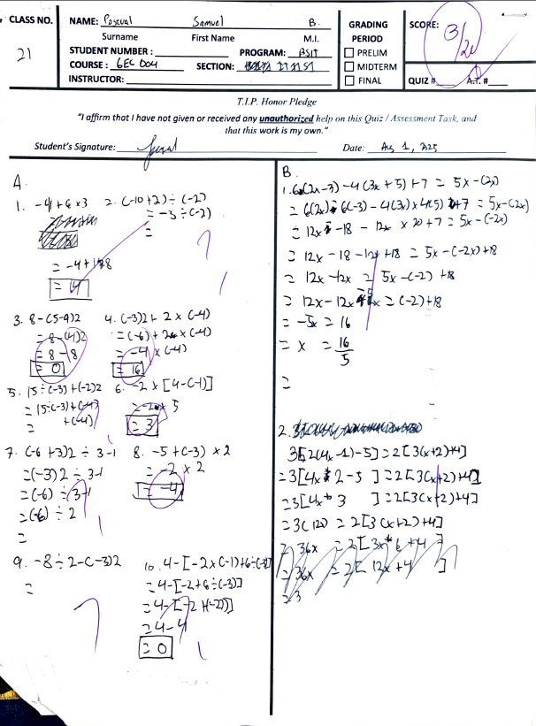

Quiz 2 (PRELIM) | Date : 08/13/2025
Proof (Screenshot)
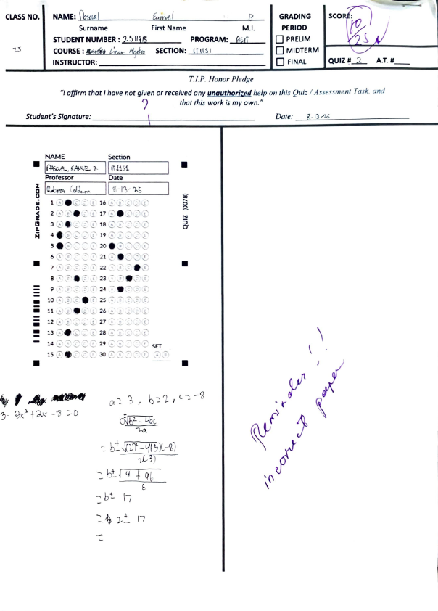
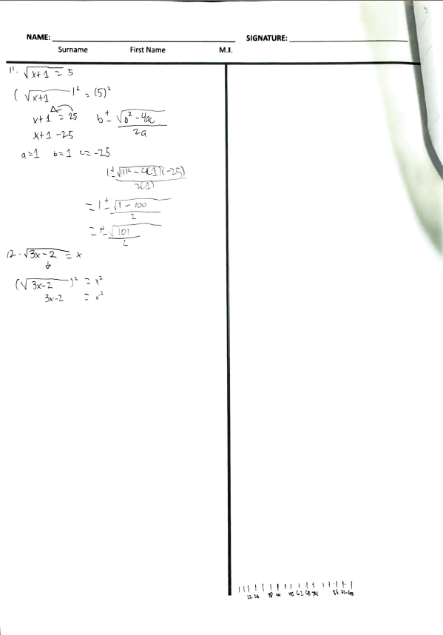

Quiz 3 (PRELIM) | Date : 08/22/2025
Proof (Screenshot)
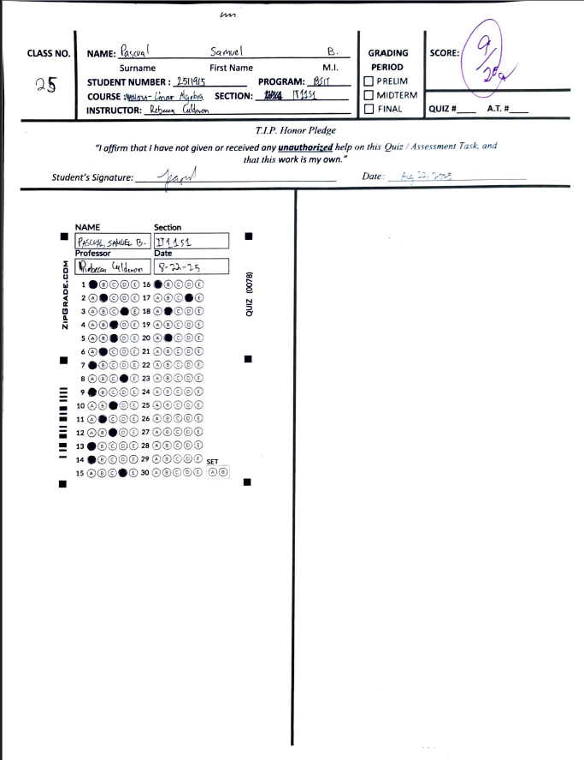

PRELIM EXAM | Date : 08/24/2025
Proof (Screenshot)
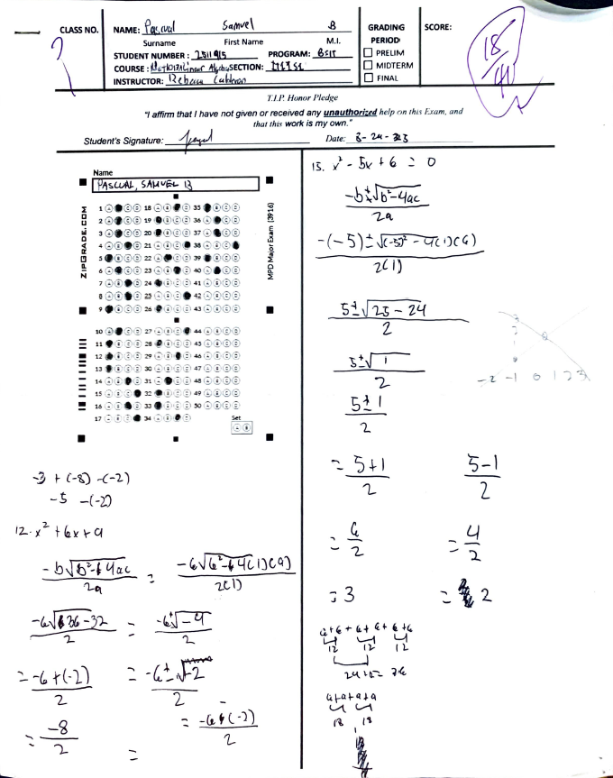

Quiz 1 (MIDTERM) | Date : 09/12/2025
Proof (Screenshot)
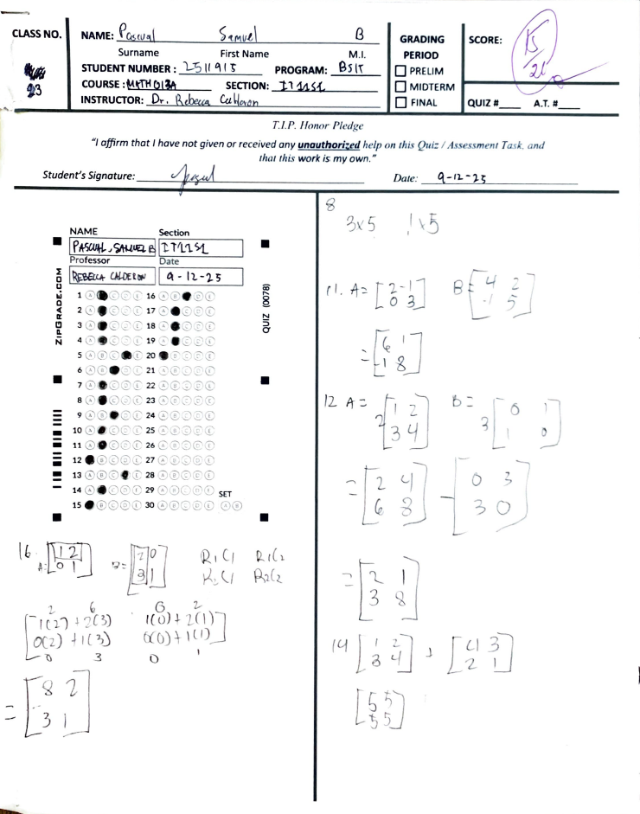

Quiz 3 (MIDTERM) | Date : 10/01/2025
Proof (Screenshot)
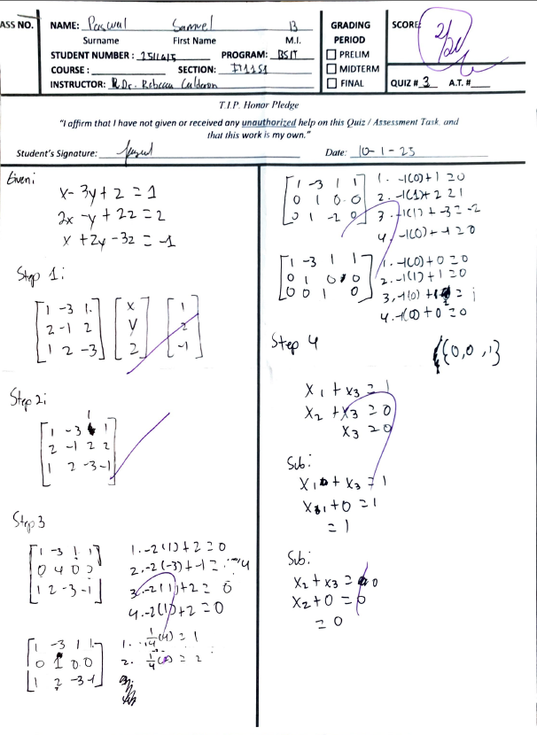

MIDTERM EXAM | Date : 10/08/2025
Proof (Screenshot)
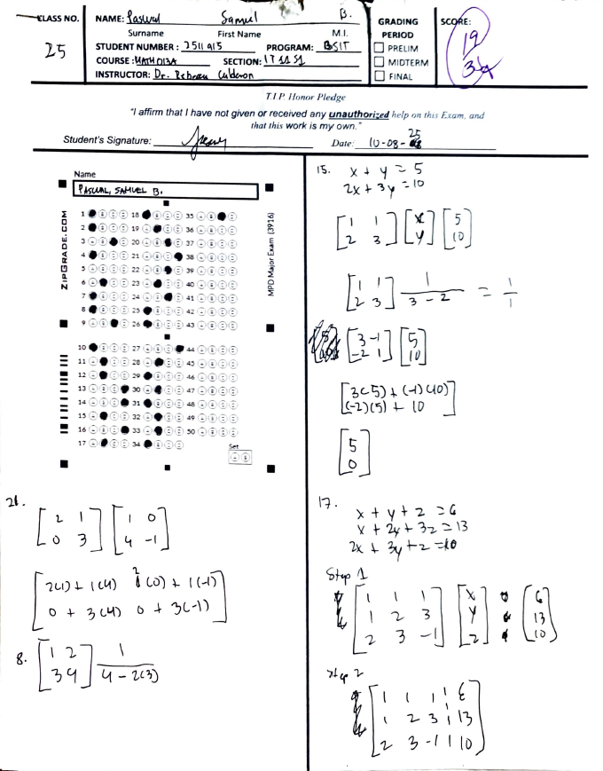

Quiz 1 (FINALS) | Date : 10/22/2025
Proof (Screenshot)
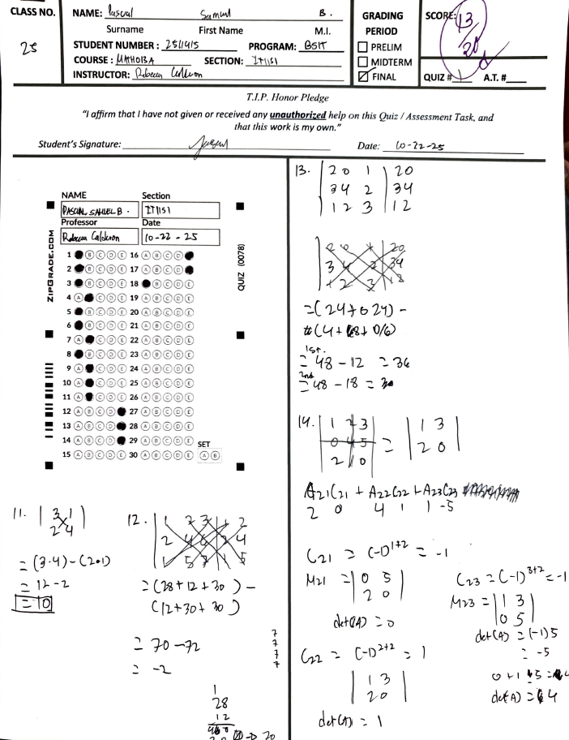
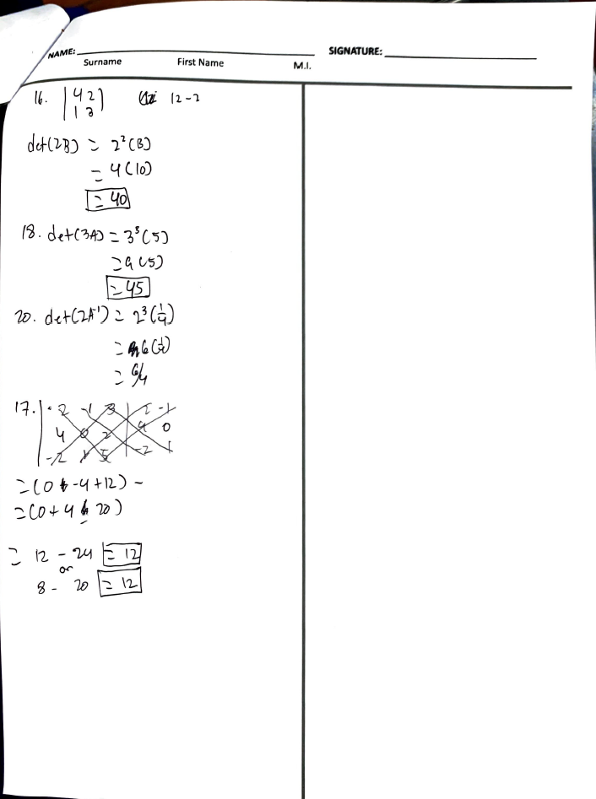

Quiz 2 (FINALS) | Date : 10/22/2025
Proof (Screenshot)
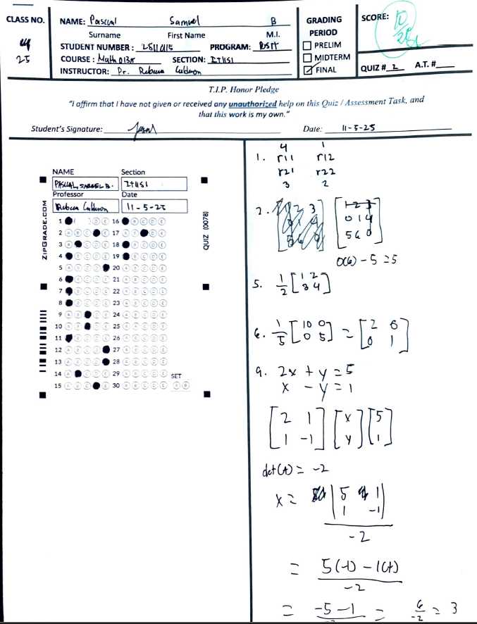
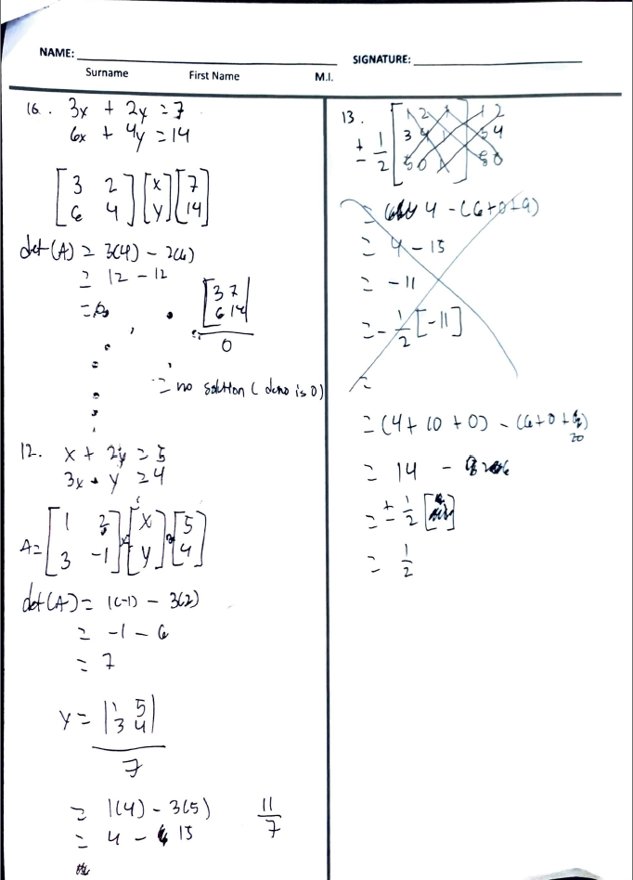
PART 3- ARIS GRADE

PRELIM
Screenshot
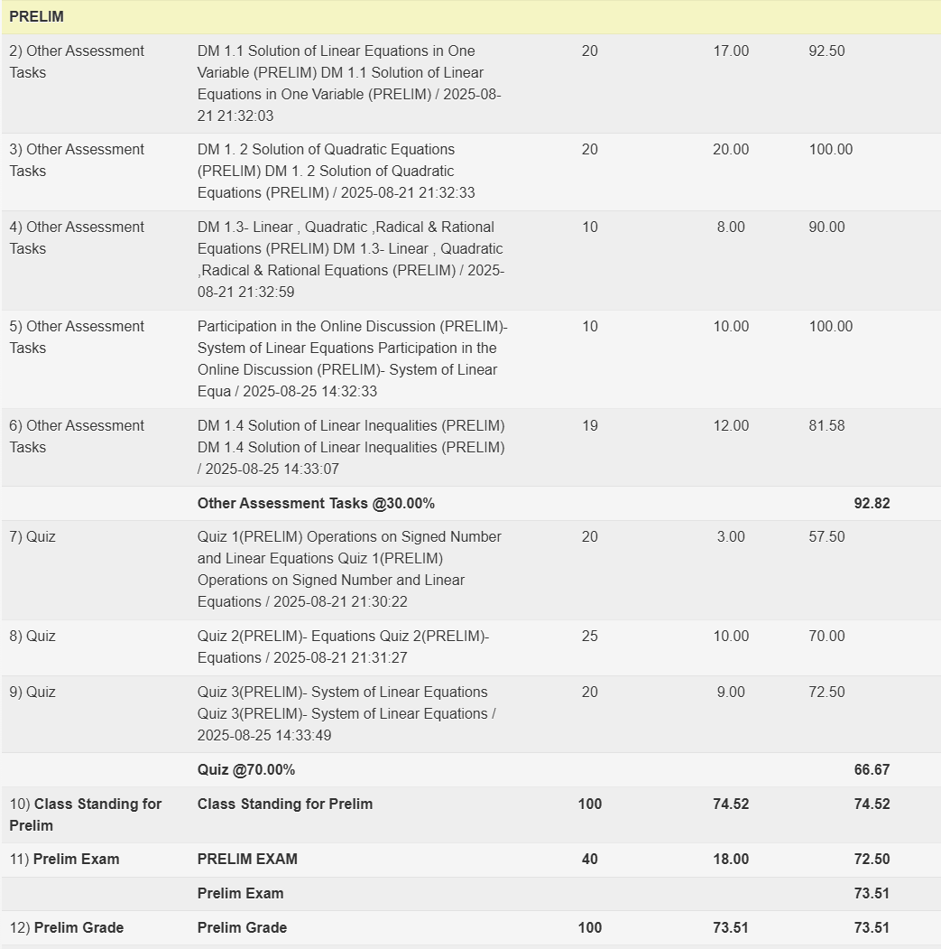

MIDTERM
Screenshot
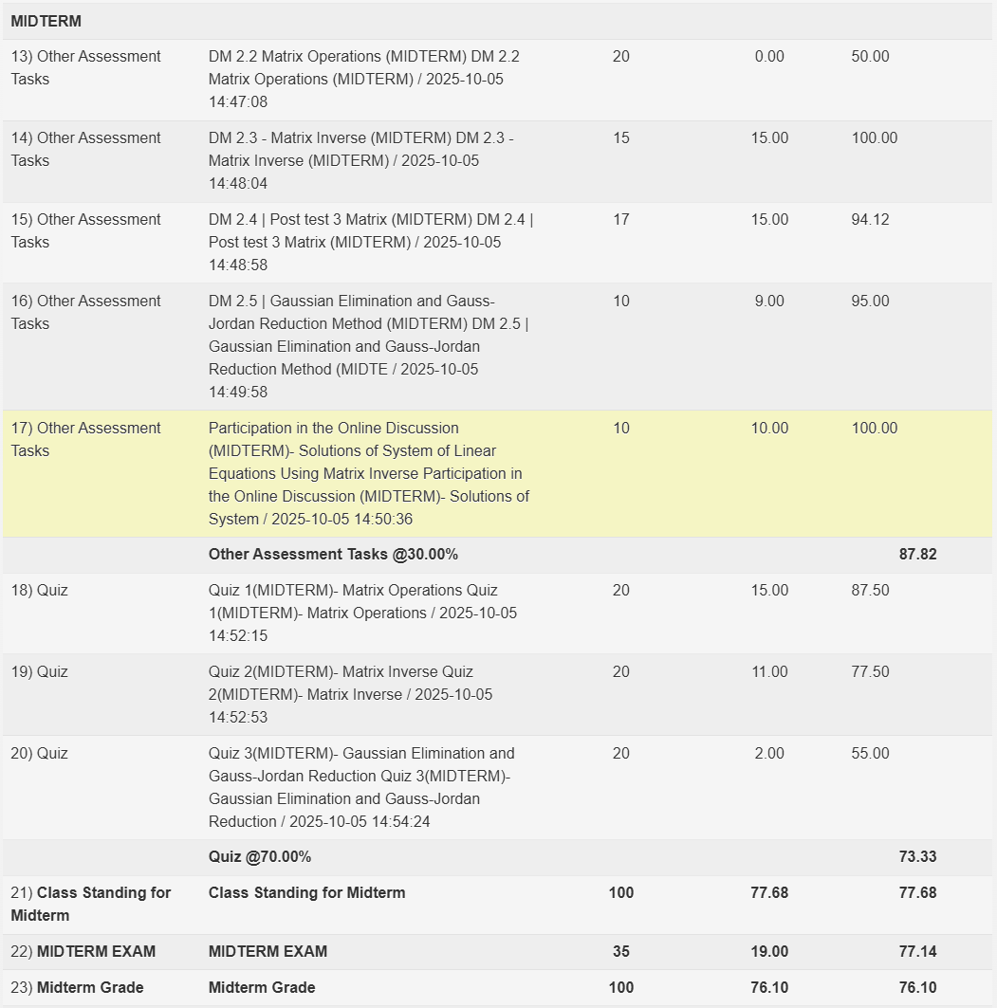

Final ( Class Standing ONLY) if available

“I affirm that I have not given or received any unauthorized help on this assignment, and that this work is my own.”

